**Marketing Strategy Development**

**Date of Submission:**

**Word Count: 2500**

**Table of Contents**

1.0 Issue One 3

1.1 Brief Description of Unilever Private Limited Company 3

1.2 Mission Statement 3

1.3 Value Statement or Slogans 3

1.4 Orientation towards Marketing 3

1.5 Products offers by Unilever and Role of Brand in Unilever’s Marketing Strategy 3

2.0 Issue Two 5

2.1 5Cs for Unilever Private Limited Company 5

a. Company – SWOT Analysis 5

b. Customers 5

c. Collaborators – Suppliers and Distributors 6

d. Competitors 6

e. Context – PESTEL Analysis 6

3.0 Issue Three 8

3.1 Collecting Information through Market Research for 5Cs 8

a. What customers want? 8

b. Which competitors pose a threat? 8

c. How the context of business is changing, if at all? 8

d. What role collaborators play in the process? 8

4.0 Issue Four: Developing Marketing Strategy 9

5.1 Marketing mix (4-7Ps) 10

References 12

# **1.0 Issue One**

## **1.1 Brief Description of Unilever Private Limited Company**

Unilever Private Limited Company is a fastest moving company in the fast-moving consumer goods (FMCG) industry that serves almost two billion of the user in a day. Unilever earns the highest turnover that counts €53.3 billion annually and possesses a market share of 58% in the FMCG industry. Along with this, only thirteen products of Unilever gives sales of more than €1 billion a year. Additionally, Unilever has a vast number of the workforce out of which 45% are female employees mainly on the managerial positions. Unilever has built strong brand image and positioned efficiently in the mind of the customers. It is considered as one of the most reliable and trustworthy brands in products and currently providing its brands in 34 different countries across the globe (Unilever, 2016a).

## **1.2 Mission Statement**

The mission statement of Unilever states that the company believes in adding energy to the life of the people. Unilever believes in providing day to day personal care, hygienic and nutritive brands to make people’s life more lively daily (Unilever, 2016b).

## **1.3 Value Statement or Slogans**

The Principles, values, and purpose of Unilever brand are to provide the highest standard of products to meet the standards of customers, corporate industry and environment as well. The core values of Unilever Private Limited Company are tied with the business operations and interaction with their customers, colleagues, and partners. The basic values include respect, integrity, responsibility, and pioneering. These core principles and values are highly useful in growing business into the new markets, hiring new talent and facing the new challenges in making day to day decisions and actions (Unilever, 2016b).

## **1.4 Orientation towards Marketing**

As stated by Urde, Baumgarth and Merrilees (2013), Unilever as of the strongest and competitive companies around the globe having successful and strong brands. In order to enter the foreign market, Unilever adopted a global marketing strategy that thinks global and acts global strategy. This global strategy applied to unify the local operations worldwide country to country in order to build company reputation and brand image. This helps in creating a strong brand image and coordinated all its marketing, distribution and operational worldwide. This strategy Unilever adopted when they were entering into the foreign markets, especially for cosmetics and toiletries products.

## **1.5 Products offers by Unilever and Role of Brand in Unilever’s Marketing Strategy**

Unilever Private Limited Company is one of the leading companies of fast moving consumer goods. It caters four main categories including personal care, food and drink, home care and water purifier. Unilever offers around 400 different products, however, the main products of the Unilever are Lipton tea, blue band, Dove, Sunsilk, Close Up, Rexona, Vaseline and many others. Moreover, according to Unilever (2016a), the company does advertising to share the benefits of the innovative products with the customers and also to engage consumers for the feedback (Shergill and Nargundkar 2005).

Furthermore, being a leading global company, Unilever promotes their products through utilizing different channels of brand communication. Here are the practical examples of brand communication in advertising and marketing strategies of Unilever. They ran an advertising campaign for their brand – Dove that targeted the stereotypes and real beauty challenges. Along with this, another advertising marketing strategy ran for the Comfort One Rinse that delivered to message to save water. According to the experts, it has been recognized that brands influence the advertising and put impacts on consumers’ to take responsibility seriously (Von Zedtwitz and Gassmann 2002). Therefore, Unilever invests more in advertising, branding, and marketing as shown in the figure below:

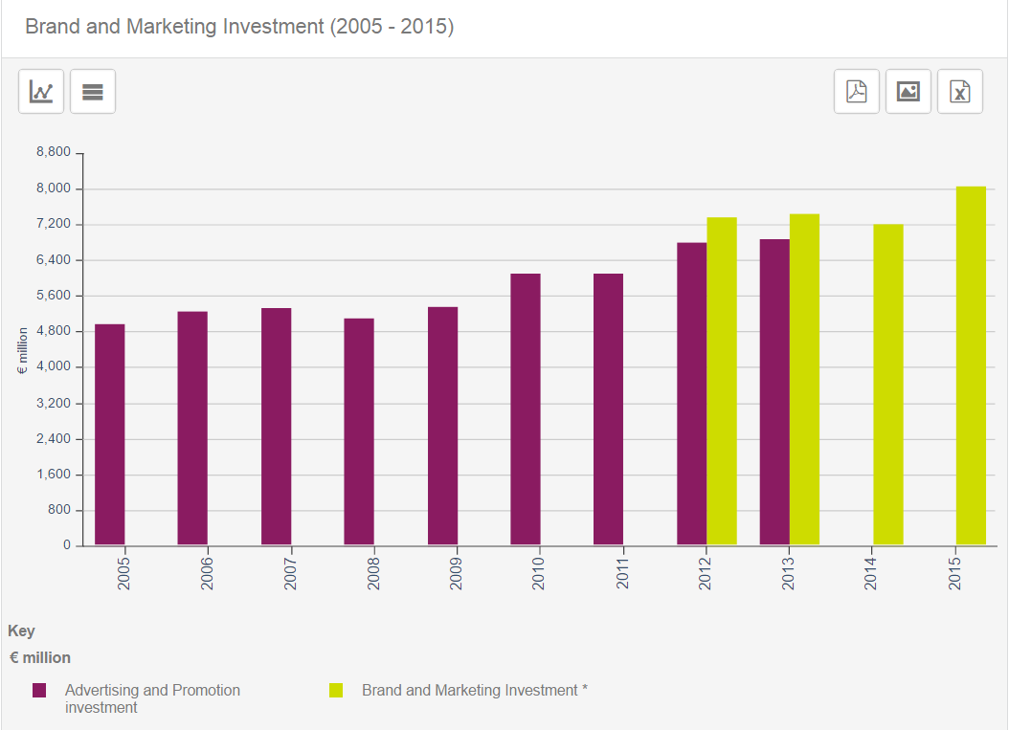

**Figure 01: Brand and Market Investment (2005 – 2015)**

**(Source: Unilever 2016a)**

# **2.0 Issue Two**

# **2.1 5Cs for Unilever Private Limited Company**

## **a. Company – SWOT Analysis**

According to Kumar, Massie and Dumonceaux (2006), the strengths of Unilever show the internal strategic factors based on company’s operations, business processes and production. Unilever’s strengths are:

* Strong Brands
* Economies of Scale
* Strong presence in the Global Markets
* Wider Product range or product mix

As stated by Kumar, Massie, and Dumonceaux (2006), the weaknesses of Unilever’s include:

* Limited diversification in business
* Strong Competition
* Substitute Products
* Intensive Reliance on Suppliers

The opportunities include the external strategic factors of which Unilever can advantage (Kumar, Massie and Dumonceaux 2006):

* Product Innovation
* Business Diversification
* Market Development
* Emerging Markets

Threats highlighted by Kumar, Massie and Dumonceaux (2006) that are faced by Unilever:

* Global competition from rivals
* New products entries
* Product imitation
* PESTEL factors

## **b. Customers**

According to the Annual Report of Unilever (2015), almost 25,000 customers use Unilever’s product per second everywhere around the world. Unilever possesses 11 millions of stores that are run by 150,000 of customers. Therefore, in order to satisfy the customers, Unilever has started a customer’s development team that acts as a partner with customers especially in launching a new product, concepts, and categories. The first category of customers are the shoppers who actually buy the products. The trends, behaviors, and habits of shoppers get noticed by the customer development teams. The next target is to cater new mindsets, then collaboration with customers and designing strategies for building a sustainable relationship with the customers.

## **c. Collaborators – Suppliers and Distributors**

Unilever has almost 76,000 number of suppliers in 190 countries all around the world that builds a strong network. The company believes in the ambitious and fast growth of the business to earn more revenues, profit, and market share. As the services and material of the suppliers are an integral part of the operations and commercial production. They ensure the presence of Unilever’s manufacturing, operations, marketing and continual improving products produce regularly. Along with this, Unilever has introduced Unilever Supplier Qualification System for providing innovative supplier and distributing solutions to the customers (Unilever, 2016a).

## **d. Competitors**

Unilever being an international brand faces strong competition not only from multinational companies that are P&G, Nestle, Reckitt Benckiser Group and others but from local or national retailers as well. In this case, factors of Porter’s Five Forces Model are applicable for the competition from the rivals (Albert, 2008). The main competition from competitors as rivals that provide same product to attract the existing customers of competitors through pricing, substitution, and several marketing strategies.

## **e. Context – PESTEL Analysis**

According to Hasan (2015), the PESTEL analysis represents the political, economic, social, technological, environmental and legal factors affecting the performance of Unilever. They have been addressed below:

* **Political Factors**

As per the report of Unilever (2014), the headquarters of Unilever are based in London and Amsterdam and the political scenarios of their countries are fluctuating especially due to the British exit the business has suffered intensively. Additionally, Unilever suffered huge loss due to political unrest in the Middle East countries mainly because Unilever earns 53% of their business directly comes from the developing countries.

* **Economic Factors**

Hasan (2015), stated that this is the most critical factor due to previous economic crisis and recession occurred all over the world. Additionally, the economic crisis gave rise to unemployment and impacted the labor wages that directly influenced the consumer purchasing rate, demand decreased and that adversely affected the profitability and revenues of Unilever.

* **Social Factors**

The social factors include the growing population, purchasing power of customers, life expectancy, aging factors and interests of consumers. These put impact on the overall profitability and productivity of Unilever (Hasan, 2015).

* **Technological, Environmental and Legal Factors**

As per the research conducted by Hasan (2015), an increasing use of technology and internet have given the innovative methods for business growth and development. Mainly the use of social media, online websites, and mobile communication have improved contact with costumers. In addition to this, Unilever is quite actively participating in environmentally friendly products and taking initiatives to reduce carbon reduction, fewer waste products and utilizing fewer resources. Additionally, Unilever has also signed legal regulations and is abide by the laws of different countries around the globe.

# **3.0 Issue Three**

# **3.1 Collecting Information through Market Research for 5Cs**

Unilever believes strong market research is an essential in understanding the market’s current position (Lee, Naylor and Chen, 2011).

## **a. What customers want?**

As stated by Lee, Naylor and Chen (2011), in the current business scenario, many companies have become consumer-centric and solely focused on consumers through providing innovative business practices. In the consumer-centric marketing research, Unilever adopted several innovative modern practices such as collaboration and direct discussions with customers, employees, and proactive ways of storytelling along with experimentation.

## **b. Which competitors pose a threat?**

Unilever being an international brand faces strong competition not only from multinational companies that are P&G, Nestle and others but from local or national retailers as well. In this case, factors of Porter’s Five Forces Model are applicable for the competition from the rivals. The main competition from competitors as rivals that provide same product to attract the existing customers of competitors through pricing, substitution and several marketing strategies (Pauwels, 2007).

## **c. How the context of business is changing, if at all?**

Unilever is renowned for having an extraordinary ability to address the macro environmental or external factors efficiently in the global consumer goods overall market. The key PESTEL analysis factors highlight the growth opportunities for Unilever in the international consumer goods market. However, the threats have also been faced by the company at macro-environmental level. Whereas, the Unilever believes in ambitious growth and expansion through concentrating on providing innovative products (Albert, 2008).

## **d. What role collaborators play in the process?**

They ensure the presence of Unilever’s manufacturing, operations, marketing and continual improving products produce regularly. Along with this, Unilever has introduced Unilever Supplier Qualification System for providing innovative supplier and distributing solutions to the customers (Lee, Naylor and Chen 2011).

# **4.0 Issue Four: Developing Marketing Strategy**

**a. A Choice of Target Market**

Potential market segments that Unilever has to consider put vast impact over company’s image and performance within the market. Similarly, market segmentation and choice of the target market are important elements for success. Segmentation comprises of demographic, cultural, behavioral and geographical aspects of the target market. Unilever has mostly targeted the international customers with middle and higher class customers. The premium prices that could deliver quality and value of money to the customers (Douglas, Craig and Nijssen 2001). However, they also focus on lower income and prices categories to increase the number of customers to purchase more products.

**b. A value Proposition for the Target Market**

According to Ulrich and Brockbank (2005), in order to gain the higher market shares and visibility in the target markets, Unilever makes a brand equity and through leveraging bigger brands. Along with this, Unilever has started to building new channels in the target markets through advertising to gain competitive advantage. It will also make a wider consumer base and assist in gaining higher profits. Along with this, the value proposition is useful in identifying customer needs, wants, interests and tastes as well. They build consumer expectations from time to time. Furthermore, Unilever can make a strong market presence and value proposition in the target markets by making partnerships with big retails stores and supermarkets to serve the desired market and get the expected growth.

**c. A Positioning Statement for the target Market**

A positioning statement reflects the way the products, services or brand have been presented to the consumers better than the competitors. Unilever has adopted several marketing strategies to position itself unique and different from competitors such as Generic strategy (Porter’s Model) that is differentiation and intensive growth strategy. The company is open to innovation in products for years and always looking ahead towards sustainable innovation among the competitors. Unilever highlighted innovation in products such as sustainable washing, better packaging and safe drinking water (Douglas, Craig and Nijssen 2001). However, Unilever is constantly looking for developing unique technologies, new business models and partnerships to make strong core capabilities.

**5.0 Issue 5: Developing Marketing Tactics**

# **5.1 Marketing mix (4-7Ps)**

Unilever implements a complex marketing mix and has been considered as the provider of the most diverse products within the market around the world. The marketing mix is based on product, price, place and promotions that represent the company’s business strategies to cater the target market. Marketing mix possesses an essential place in the success of Unilever, as the price and promotional components reflect the profitability of the company. Being a leading company, Unilever maintains high marketing mix to address the competitors and challenge the global market (Chen and Green 2009).

* **Product**

Unilever brand and product portfolio is composed of around 400 different product mix and brands. This basically identifies Unilever’s output and the product range includes the foods, home and personal care and beverages products. In the marketing strategy, Unilever can apply both growth intensive and generic strategy through introducing new innovative products in different markets (Chen and Green 2009).

* **Place**

The places include the presence of Unilever all around the world. This can be done through using a marketing strategy that is market penetration a primary strategy for intensive growth. Further, marketing development strategy can also be applied for targeting the new markets such as Unilever can grow by marketing its current products as a new solution to unaddressed needs in certain market segments, such as infant care needs (Chen and Green 2009).

* **Price**

In the marketing mix, pricing is an important element and Unilever serves a wide range of prices and follows several pricing strategies due to the product diversification. However, the most significant pricing strategies Unilever implements in consumer goods business are the premium pricing strategy, market-oriented pricing strategy, and product bundle pricing strategy. Further, In market-oriented pricing strategy, Unilever applies market competitive and competitor’s pricing to determine the standard price. However, in premium pricing strategy Unilever offers higher prices of the products than competitors (Chen and Green 2009). In the end, at time Unilever also offers discounted rates occasionally for the premium quality brands.

* **Promotion**

According to Chen and Green (2009), due to intense market competition, Unilever needs to promote its products vastly to beat the competitors and rivals within the consumer goods industry. The strategies that Unilever adopts in promoting the products and to reach the target audience and consumers. This includes advertising, direct marketing, sales promotions, personal selling and public relations. However, Unilever is also applying online promotional strategies to reach out the customers. Unilever mainly relies on promotions and advertising to positively influence the consumer perception about the company.

# **References**

Albert, U.F., 2008. PESTEL ANALYSIS: A REPORT ON UNILEVER.

Chen, H.C., and Green, R.D., 2009. Marketing mix and branding: Competitive hypermarket strategies. *International Journal of management and marketing research*, *2*(1), pp.17-34.

Douglas, S.P., Craig, C.S. and Nijssen, E.J., 2001. Integrating branding strategy across markets: Building international brand architecture. *Journal of International Marketing*, *9*(2), pp.97-114.

Douglas, S.P., Craig, C.S. and Nijssen, E.J., 2001. Integrating branding strategy across markets: Building international brand architecture. *Journal of International Marketing*, *9*(2), pp.97-114.

Hasan, M.M., 2015. Marketing Analysis of Unilever. *Total Quality Management*, *11*, p.13.

Kumar, S., Massie, C. and Dumonceaux, M.D., 2006. Comparative innovative business strategies of major players in cosmetic industry. *Industrial Management & Data Systems*, *106*(3), pp.285-306.

Lee, R.P., Naylor, G. and Chen, Q., 2011. Linking customer resources to firm success: The role of marketing program implementation. *Journal of Business Research*, *64*(4), pp.394-400.

Pauwels, K., 2007. How retailer and competitor decisions drive the long-term effectiveness of manufacturer promotions for fast moving consumer goods. *Journal of Retailing*, *83*(3), pp.297-308.

Shergill, G.S. and Nargundkar, R., 2005. Market orientation, marketing innovation as performance drivers: extending the paradigm. *Journal of Global Marketing*, *19*(1), pp.27-47.

Ulrich, D. and Brockbank, W., 2005. *The HR value proposition*. Harvard Business Press.

Unilever 2016a. About Us. [Online] Available at <.https://www.unilever.com/about/>. [Accessed on 19th December 2016].

Unilever 2016b. Purpose and Principles. [Online]. Available at: <.https://www.unilever.com/about/who-we-are/purpose-and-principles/>. [19th December 2016].

Unilever 2016c. Advertising and Marketing. [Online] Available at: <.https://www.unilever.com/sustainable-living/what-matters-to-you/advertising-and-marketing.html>. [Accessed on 19th December 2016].

Urde, M., Baumgarth, C. and Merrilees, B., 2013. Brand orientation and market orientation—From alternatives to synergy. *Journal of Business Research*, *66*(1), pp.13-20.

Von Zedtwitz, M. and Gassmann, O., 2002. Market versus technology drive in R&D internationalization: four different patterns of managing research and development. *Research policy*, *31*(4), pp.569-588.